HEADQUARTERS: Glencrieff, Pinebank Kennels 7111 Concession 1, Puslinch, ON
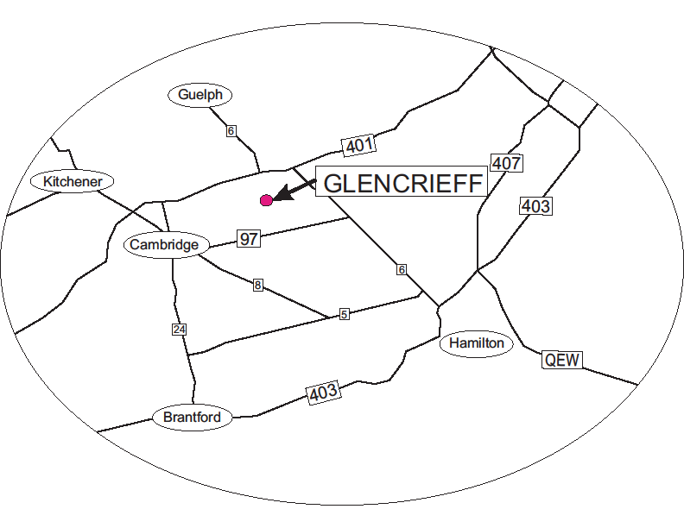Hunt Test will be conducted on the grounds of Pinebank Kennels and at various local properties in the Puslinch area.

ACCOMMODATIONS:
Camping – Valens Lake Conservation Area, Regional Road 97,
905-659-7715 to reserve
Days Inn by Wyndham Guelph: 785 Gordon St, Guelph, Ontario. 519-822-9112 (a CKC sponsor and affiliate)

The Comfort Inn Cambridge accepts dogs
220 Holiday Inn Drive,
Cambridge, Ontario
519-658-1100

Veterinary Medical Services:
A Veterinarian is present on site at head quarters
Emergency clinic: 405 Maple Grove Road, Unit 14,
Cambridge Ontario, N3E 1B6 519-650-1617



Official Premium List
HUNT TEST
Limited Entry
Open to all Retrievers, Irish Water Spaniels, Barbets and Standard Poodles

May 24 & 25, 2025

TEST SCHEDULE:
Test | Date | Start Time | Judges
JH | Sat. May 24 | 9:00 am | Andy Mikolaiczyk & Gary Charchalis
SH | Sat. May 24 | After JH Land | Andy Mikolaiczyk & Gary Charchalis
MH | Sat. May 24 | 8:00 am | Tracey Griffin & Stephen Payton
JH | Sun. May 25 | 9:00 am | Pat Van Bregt & Wendy Hunter
SH | Sun. May 25 | After JH Land | Pat Van Bregt & Wendy Hunter
MH | Sun. May 25 | 8:00 am | Tracey Griffin & Susie Bell

Entries will be accepted only through Dogshow.ca

Entries open Wednesday April 30th , 2025 at 7:00 pm and close Friday, May 16, 2025 at 8:00 p.m. or when test fills.



Only those entries submitted in the manner outlined in this Premium List and received BEFORE the Closing date will be accepted.

These events held under the rules of
The Canadian Kennel Club

Maximum combined JH SH entries each day 25 dogs

Maximum MH entries each day 25 dogs

Zero Tolerance Policy
The Labrador Owners Club is a volunteer organization, dedicated to the improvement and well being of the Labrador Retriever. The LOC organizes, promotes, and offers to LOC members and members of the public, events that showcase the talents of the handlers and their dogs. We strive to promote good sportsmanship among all participants and spectators at each of our events.
Please be Advised:
The Labrador Owners Club has ZERO tolerance for abuse (or harsh handling) of any kind to any person or animal present at any of our events. This includes, but is not limited to, judges, organizers, volunteers, competitors, animals, and members of the public.
Failure to comply could result in immediate removal from the event and the site, up to and including a permanent ban from any and all future Labrador Owners Club events. The decision to remove from an event is at the discretion of the LOC event organizers present in consultation with members of the LOC Executive. A permanent ban will be determined after a thorough review of the incident by the LOC Executive. The person under review will be advised of the final decision upon completion.

TEST DETAILS:
- Standard CKC rosettes awarded to all qualifying dogs
- Ribbons will be given out at the end of each stake
- Ducks will be used for land and water, pheasants for upland
- Shotguns may not necessarily be used
- Hunt test handlers shall be attired in dark or customary hunting attire.
- Requests refunds will be given for bitches in season. A Veterinarian certificate must be submitted prior to test
- Requests for refunds for injuries sustained after the closing date of test must accompany a letter from a veterinarian and be received before the day of the test
- Recommended arrival time is ½ hour prior to the start time for each stake.
- Entrants may be required to help with gunning and other volunteer positions required in the running of the test.

The Labrador Owners Club is a member in good standing with the Canadian National Master Retriever Club. As of July 1, 2010 only passes at Hunt Tests hosted by clubs in good standing of the Canadian National Master Retriever Club are considered in determining eligibility to enter the National Master Hunt Test Stake.

ENTRY INFORMATION:
Entry fees:
 | Non-Members | LOC Members *
JH | $60 | $55
SH | $65 | $60
MH | $70 | $65
*Must be LOC Member effective March 1, 2025

All owners of unregistered, CKC-recognized breeds entering events are required to obtain a Temporary Competition Number (TCN).

TCNs are replacing the current system of entering events with dogs as “listed”, and allow dogs to temporarily participate in CKC events while they pursue permanent registration or an Event Registration Number (ERN).
- A TCN must be obtained before submitting an entry for an event.
- The same TCN must be used for all event entries for a dog until the dog is permanently registered or has an ERN.
- A TCN cannot be used for Listed Breeds with an MCN (Miscellaneous Competition Number) or dogs that will require a PEN (Performance Event Number) or CCN (Canine Companion Number).

TCNs can be obtained:
- Online through CKC’s Portal (Note: Individuals who have not yet used the online Portal will be required to create a Portal account before they can submit a TCN application online);
- By submitting a completed paper application by mail to CKC; or
- By contacting the Shows and Trials Division Toll Free at 1-855-364-7252.

.

Test Secretary
Katherine Kirkpatrick  114 Forest Street East  Dunnville, ON  N1A 1C1 | Email: thelocsecretary@gmail.com
Phone: 289-377-9940
** Calls between 9 am and 9 pm, please**

Excerpt from the CKC Rules & Regulations for Hunt Tests (section 2.5)
2.5.2: Electronic collars (either dummy or live) as well as prong/pinch type collars shall not be worn by a dog on the grounds of a Hunt Test at any time during the event with the exception of those collars designed to curtail barking which may be worn by a dog while kenneled.

Excerpt from the CKC Rules & Regulations for Hunt Tests (section 3.8)
3.8.1: A judge officiating at a hunt test held under these rules shall not be subjected to any indignities of any kind during the progress of the hunt test. It shall be the duty and obligation of the club holding the hunt test to see that this rule is effectively carried out.

JUDGES ADDRESSES:
Tracey Griffin tracey@cedarbraelabs.ca Ladysmith BC
Pat Van Bregt Patvanbregt@gmail.com Ancaster ON
Gary Charchalis quincyhunter@hotmail.com Amaranth ON
Steve Payton spayton100@yahoo.com Courtland ON
Susie Bell slbell@gto.net Puslinch ON
Wendy Hunter Wendy.goldens@gmail.com Burlington ON
Andy Mikolaiczyk A.Mikolaiczyk@manulifewealth.ca Aylmer ON

TEST COMMITTEE:
Chair: Liz Pask
Co-chair: Katherine Kirkpatrick
Secretary: Katherine Kirkpatrick
Equipment: Harold Weiderman

LABRADOR OWNERS CLUB EXECUTIVE:
President: Sharon Sandwell
Past President: Sandy Straw
Vice President: Cindi Nash
Secretary: Katherine Kirkpatrick
Treasurer: Al Dundas
Communications: Maryanne Voogt

CKC OFFICERS:
Executive Director Jeff Cornett ED@ckc.ca

Zone 6 Director Peter Scott zone6director@ckc.ca

Retriever Hunt Test Tim Marshall
Council Rep Zone 6 16 Sleeman Ave., Guelph, ON, N1H 6E9

LUNCHES Please bring your own lunch or a variety of fast food options are available within 10 minutes of the test head quarters.

If the test fills and you wish to go on a wait list this option will now be available through Dogshow.ca.

RAFFLE TABLE, 50/50 DRAW, NQ Draw
A raffle table and silent auction will be part of the festivities this year. Make sure you come by and check out all the great stuff!

Volunteer ONLY Raffle

The LOC appreciates the efforts of all volunteers. Help out and gain a chance to win prizes. It takes a village to run a hunt test!
Contact trial secretary by closing date if you would like to help out

Lunch is available for current LOC members and for gunners/blind planters and marshals. Please contact the secretary if you wish to help.

TAILGATE PARTY

We will be holding a Tailgate Diner on Saturday, May 24th on the grounds of Pinebank Kennels at the conclusion of master hunter test. Please plan to join us for a Dinner $10.00 per person and enjoy the gourmet talents of Mel Gagnon). Meet new people and catch up with old friends enjoy the raffle and the you can rsvp though Dogshow.ca when you enter.

USED BIRD SALE

Some used birds will be available for purchase on Sunday May 25 after the hunt test on a first come, first serve basis. Birds are $5.00 per bird.

By entering this test, I CERTIFY that I am the registered owner(s) of the dog or that I am the authorized agent of the owner(s) whose name(s) I have entered above and accept full responsibility for all statements made in this entry. In consideration of the acceptance of this entry I (we) agree to be bound by the rules and regulations of the Canadian Kennel Club and by any additional rules and regulations appearing in the premium list. Also, by entering this event, I certify that I will not hold the Test giving Club, its members, directors, employees, volunteers or agents liable in the event of any accident of misfortune however caused.

